Now religion is everywhere, which is just fine if it means less crime, divorce, and violence; but history also taught us that religion applied through the government, always becomes tyrannical.
According to the countdown of prophecy, conditions will become so bad, with the natural disasters, political mis-management, and war among nations, that the world's people will ask the Vatican to take over, as a last resort.
From nearly defeated in the early 19th century, to becoming almost a world power itself in our times, it is rapidly fulfilling this prophecy before our very eyes! Have you noticed how politically powerful, and popular, the pope has become just in recent times?
But it will be a terrible mistake. The Vatican will require all to obey its dictates, as opposed to the way of God. Everyone will have to take a stand, whether to be on the side of the pope or on the side of God. But God is going to win. He wants you to choose His side, too!

God has a hard time getting us to pay attention. We work hard, play hard, cram a million things into a week, and weekends. We aren't seeing the train coming around the bend. How can He wake us up, except by shocking us into it?
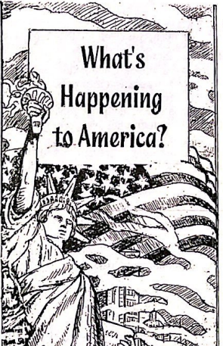
Sometimes we just shut out the bad news all around because we feel helpless to do anything about it. But you CAN do something about your relationship with God. He does respond to you—in person. He loves you, and wants you to be saved!
God has not left us without information on His awesome return. The books of Daniel and Revelation tell us, in surprising detail, how events will take shape in these final days.
The strange beasts and scenes of the prophecies are not Bible sci-fi, not meant to be mysterious cartoons. They are symbolic of the nations which arise to power through history, right down to our modern times! The seas represent people, the stars represent important rulers, etc. The Bible itself tells what the symbols mean, and you can find those to prove everything as you go.
This is God's 911 call to you.
Will you answer?
Just fill in the enclosed card for more information. Bible lessons, books, and DVD's are available.
No donation is asked.
Truth Triumphant
P.O. Box 1417, Eustis, FL 32727-1417 Ph. 863-287-9193
www.truthtriumphantministries.org
Almost anyone you meet can recall exactly where he or she was when the news came about the World Trade Center. In outrage, we witnessed sights we never thought could happen in the great United States! Our sense of security here was shattered about as fast as those great world icons fell to the ground!

Where was God in this terrible tragedy that took so many lives of hard working citizens, firefighters, and rescuers? There is the argument that God will not go on protecting a nation that persists in its defiance against Him. Does this mean that everyone in the Twin Towers deserved to die?
So, how do we reconcile with the Bible's declaration over and over that God loves us? We have these urgent questions and we look to our faith and our friends for answers. Yet, after all is said, we can only admit "For now we see through a glass, darkly, but then face to face..." I Cor 13:12. We need some shred of reason and justice in it all.
Why doesn't God do something about evil and violence? He could have wiped out rebellion when it first appeared in His universe. But then people would serve Him out of fear. God wants only willing and intelligent allegiance to Him.
He has allowed this defiant experiment with lawlessness, to prove what a failure it is, what misery is created, when those who have power and means oppress and manipulate the citizens of their nation. But prophecy tells us that time is up. God is going to bring this to a conclusion. We need to be ready!
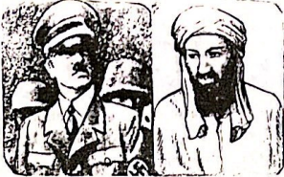
The prophecies in the books of Daniel and Revelation were given to outline Satan's plans to defeat God's people in the time of the end. They reveal the succession of nations through history, and describe world rulers, crooked politicians, and dishonest organizations, even into our present time. It's so very important not to be deceived into choosing the wrong side, and becoming one of the lost in the end. Read this in Rev 20:14.
God is withdrawing His protection from the world!
Here is a good question for you. Do you think that Satan, and world leaders through which he works, will just humbly bow aside while Christ comes back to do away with their evil plans of domination? Certainly not! So afraid are we of any hint of "conspiracy theory" that we remain pridefully ignorant of the plans that any dictator, or world ruler, would do to protect his domain when threatened. Just read any history book if you doubt this.
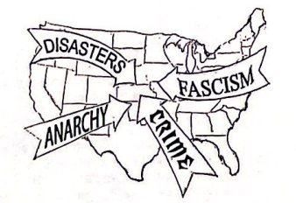

The recent news broadcasts of unimaginable greed and corruption, perpetrated by stealthy politicians and the financial elite should make us alarmed enough to sit up and hear the foundations rumbling.

Decisions by the government that seem harmful and absurd are not just someone's poor judgment, not just from your imagination. They make cunning sense to those who are not the friends of America or God.
Bible prophecy repeatedly tells of a religio-political power in the last days, with its vast monies and international prestige, that will take control in our modern times. You need to know how this works. It is clearly defined in the books of Daniel and Revelation.
America, and the world, are going to become religious again. In the fifties and sixties, religion was not discussed in the main media. Science was going to be the great answer to everything.

